
Population Analysis Committee
Study List Recommendations

Board of Education Meeting
February 4, 2014

Fox Hills (7 relos) with 676 school students and 167 GT Magnet students= 843
School | Enrollment | Bldg. cap | History
Fox Hills | 843 | 700 = 120% | 798, 852, 877, 842
South Kearns | 396 | 535 = 74% | 396, 390, 399, 396

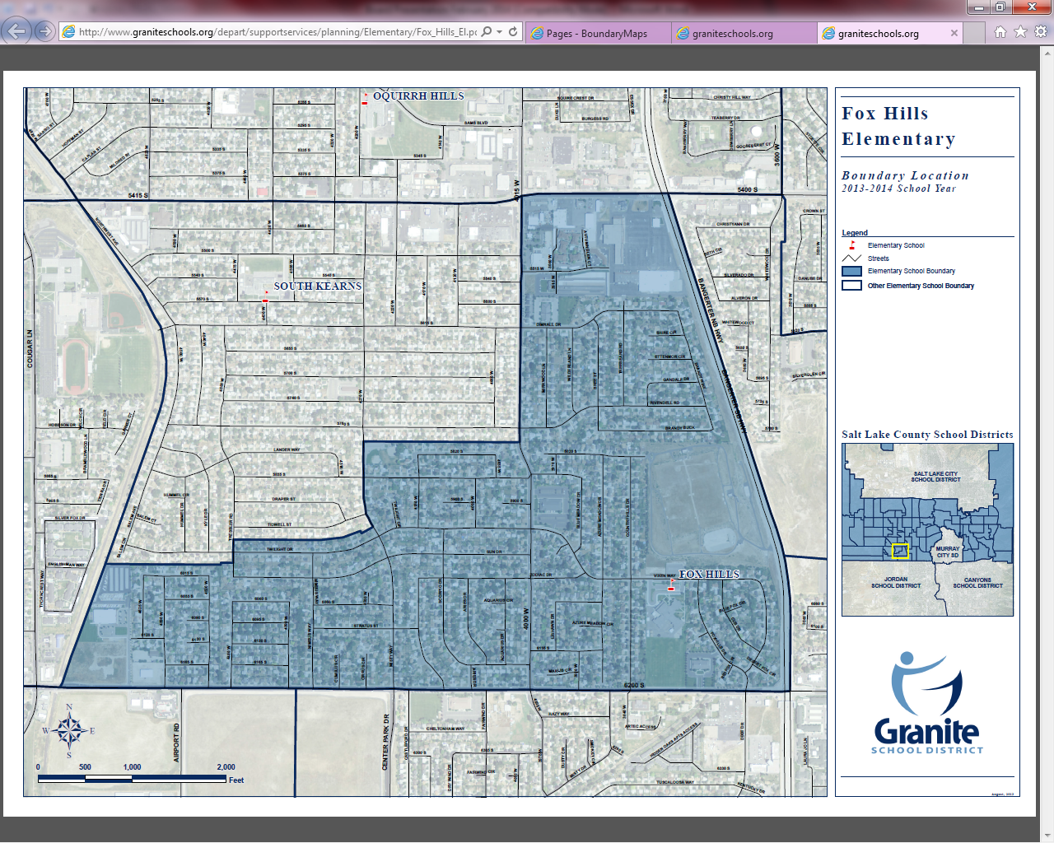
Bennion Elementary and Westbrook Elementary feed into Bennion Junior High. Fifty percent of the Bennion Elementary boundary and 100% of Westbrook Elementary boundary feed into Cottonwood High. (Map)
Taylorsville High School Community Council and Bennion Junior High Community Council have formally requested to have these boundaries changed from being in the Cottonwood High boundary and to be aligned in the Taylorsville High boundary.


